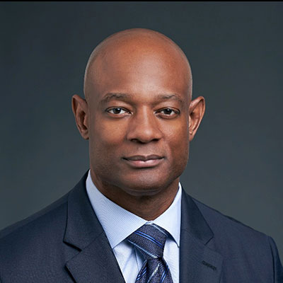

Dr. DeVry C. Anderson, MD, MBA, FACHE, CPE
Chief Medical Officer St. David’s South Austin Medical Center

AUSTIN, Texas—St. David’s South Austin Medical Center has appointed a veteran of both the military and the medical profession as its new chief medical officer. DeVry Anderson, M.D., has served as the facility’s associate chief medical officer since September. He transitioned to his new role after Albert Gros, M.D., who served as chief medical officer for more than 30 years, retired in April.

“Dr. Anderson has transitioned seamlessly into this role amidst a global pandemic unlike anything we have seen in our lifetimes,” Charles Laird, chief executive officer of St. David’s South Austin Medical Center, said. “I am confident he will continue to build upon the exceptional level of care provided at St. David’s South Austin Medical Center.”

A board-certified family medicine physician, Dr. Anderson comes to St. David’s South Austin Medical Center from the Carl R. Darnall Army Medical Center in Fort Hood, Texas, where he was vice president of medical services. In this role, he oversaw the quality, safety, patient experience and large scale integrated delivery of care for a 155-bed inpatient medical treatment facility with facility business performance planning in 22 hospital departments comprised of 1,350 clinical staff. In addition, Dr. Anderson was responsible for the clinical skills sustainment and training for two Graduate Medical Education (GME) accredited residency training programs (Emergency Medicine and Family Medicine) and their corresponding clinical departments.
Previously, Dr. Anderson served as a U.S. Army Colonel, and he retired following a distinguished career of service, with assignments that included serving in several combat operations. He oversaw the healthcare of thousands of servicemen and women preparing for deployment, those already deployed, and those who had suffered injury or illness while serving as members of the U.S. Army. He is a highly decorated veteran and is the recipient of the Bronze Star Medal awarded for valor in combat. Dr. Anderson also helped lead medical operations associated with the U.S. Army’s participation in the Hurricane Katrina relief effort.

In addition to his military and medical credentials, Dr. Anderson is a West Point graduate, earned a master’s degree in business administration from Norwich School of Business in Vermont and completed graduate studies in strategic leadership at the U.S. Army Command and General Staff College, as well as the Executive Leadership Program at Harvard University’s School of Public Health. He holds adjunct professorships in medicine at the F. Edward Hébert School of Medicine, Uniformed Services University of the Health Sciences and Texas A&M Health Science Center College of Medicine. He is also a Fellow of the American College of Health Care Executives.

