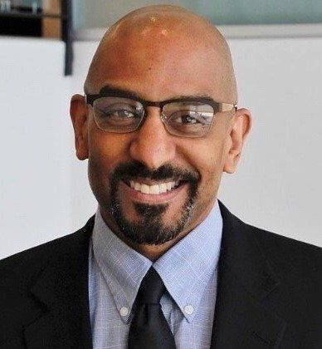

Dr. Jeff Hutchinson
Founder and CEO The Wade Alliance

Jeff Hutchinson, MD uses his expertise in leadership, communication and education to help organizations address change and resolve conflicts. As a retired US Army Colonel, Adolescent Medicine specialist, and former Chief Diversity Officer he possesses the skills necessary to guide organizations through changes. With a Bachelor of Science degree in Chemistry from the United States Military Academy and his medical degree from the University of California San Francisco his career includes combat in Iraq, clinical and organizational leadership at the Uniformed Services University of Health Science School of Medicine.

With 25 years of experience caring for children, teens, young adults and service members his unique approach combines the science of behavioral economics with the methodology of helping teens and parents communicate. He is an advocate for addressing the social determinates of health disparities and has published in several academic journals. As an executive member of the American Academy of Pediatrics Council on Communication and Media he emphasizes communication and works to help others communicate more effectively.

